Pilot SQAP audit on design invalidity decisions



From 10 to 11 September 2019, the EUIPO welcomes users to their first pilot audit on the quality of EUIPO design invalidity decisions (out of the eleven SQAP audits have taken place so far).

Eleven users representing nine user associations are meeting at the EUIPO’s premises to check a sample of decisions against our quality criteria.

The audit participants and their respective user associations are

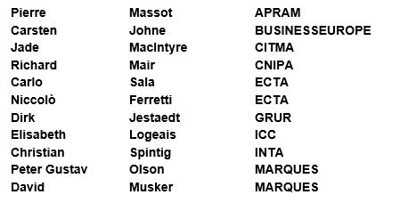

SQAP is a project launched by the EUIPO in 2017 aiming to integrate the user’s perspective into the quality management system and to narrow the gap between the users’ perception of quality and the quality measured by the Office. In SQAP, users contribute directly to improving the quality of the Office decisions.

The EUIPO would like to thank the users and user associations for taking part in this initiative.

For more information on SQAP, please visit the [SQAP webpage](https://euipo.europa.eu/ohimportal/en/sqap_audits).